**Exercise 4: Arrange-Act-Assert (AAA) Pattern, Test Fixtures, Setup and Teardown Methods in Junit**

**Scenario:**

Need to organize the tests using the Arrange-Act-Assert (AAA) pattern and use setup and teardown methods.

**Code:**

**Calculator.java  
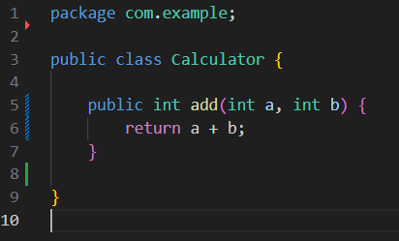**

**CalculatorAaaTest.java**

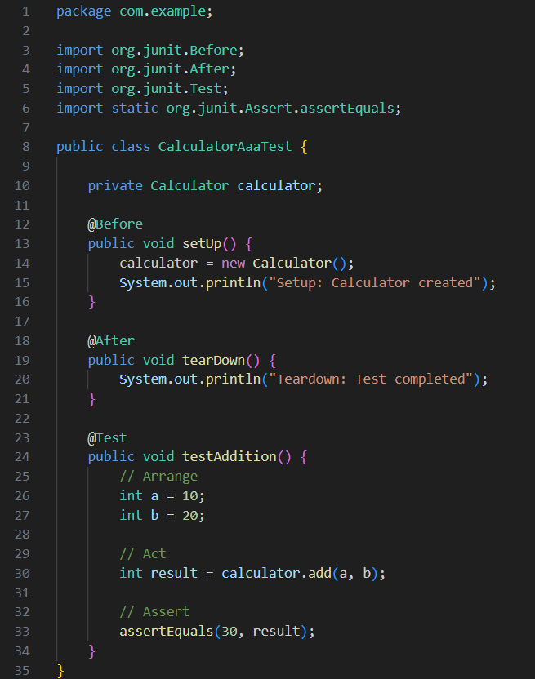

**Output:**

